Nama : Muhammad Huda Fatoni

Nim : L200170062

Kelas : C

Modul 11

Induksi aturan data cuaca

Rule Model

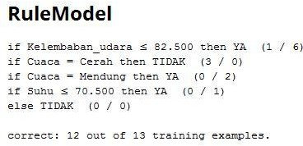

Vector

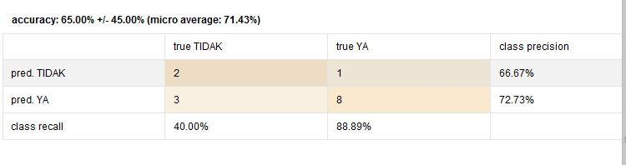

Aturan asosiasi Data cuaca

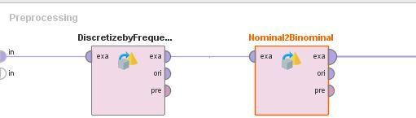

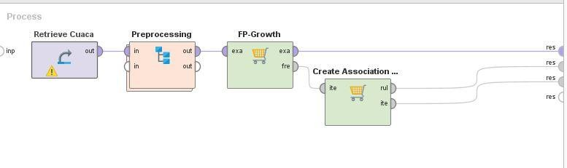

|  |  |  |  |  |
| --- | --- | --- | --- | --- |
| Site | 5upporl Item 1 | Item 2 | Rem3 | Item 4 |
|  | 0.500 Kelembaban_udara |  | | |
|  | 0.4-29 Berangin |  | | |
|  | 0.429 Suhu |  | | |
|  | 0.357 Cuaca = Cerah |  | | |
|  | 0357 Cuaca = HuJ an |  | | |
|  | 0286 Cuaca = llendung |  | | |
|  | 0.24 4 Kelembaban_udara | Berangin | | |
|  | 0.24 4 Kelembaban_udara | Suhu | | |
| 2 | 0.2 4 Kelembaban udara | Cuaca = Cerah | | |
| 2 | 0143 Kelembaban udara | Cuaca = Hujan | | |
|  | 0M43 Kelembaban_udara | Cuaca = ldendung | | |
|  | 0143 Berangin | Suhu | | |
|  | 0143 Beran gin | Cuaca = Cerah | | |
| 2 | 0143 Beran gin | Cuaca = Hujan | | |
| 2 | 0143 Berangin | Cuaca = klendung | | |

|  |  |  |  |  |  |  |  |  |
| --- | --- | --- | --- | --- | --- | --- | --- | --- |
| to. | Premises | COfiCltt S toft | Support | Confden... | La Pla... | Gain | p-s | Lift |
| 1 | Berangin, Suh u | Cu aca = C era h | 0.143 | 1 | 1 | -0.143 | 0.092 | 2.8 0 0 |
|  | Berangin, Cuaca = Cera h | Suhu | 0.143 | 1 | 1 | -0.143 | 0.082 | 2.333 |
| 3 | Kelem tab an_udara, Bera... | Cu aca = C era h | 0.071 | 1 | 1 | -0.071 | 0.046 | 2800 |
| 4- | Kelem Lab an_udara, Bera... | Suh u | 0.071 | 1 | 1 | -0.071 | 0.041 | 2333 |

Rule 4 (0.07'l / 1.000)

Kelembaban_udara

Rule 3 (O.07't / 1.000)

Suhu Cuaca = uerah

Rule 1 (0.143/ 'I.000)

Rule 2 (0.143/ '1.000)

